Judge Instructions MS
Thank you for judging and giving your time to the Debate Program. We cannot run tournaments without judges and your support is appreciated.
Remember, these are middle school kids. We want them to have feedback, but they still need some encouragement. The comments/feedback should be constructive. If we just write “good job,” but they place last, they don’t know what to work on. Even if they place first, let them know what they did well so they can keep doing it, but let them know what they could also improve on. The students can’t wait to see the comments on the ballots, and the coaches use those to help coach the students after the tournaments.

Important comments:
-As soon as you enter the room, click the button start round in Speechwire. Make sure you complete your comments while you are judging and complete the rankings as soon as possible so we can start the next round. Often, we are waiting on judges to finish the previous round and cannot start the next round.
-Go ahead and start even if all competitors are not there yet, they may be lost. For debate rounds, if the other team is not there yet, wait a few minutes…after about 10, send the room monitor or hall monitor to the tab room in the media center.
-Leave the trash can in the door of your room, unless there is a room monitor in there.
If you have an issue, send the room monitor/hall monitor to the media center to the tab room with the issue. Do not leave the room.

For speech events:
-You must rank 1-7, there are no ties. For speaker points, it should be 90-100. First place does not have to receive 100 points, but each competitor must have different points in the order of the ranking.
-All speech events have a 30 second grace period which means if they speak within 30 seconds over their time, they are ok on time. Once they go over the 30 second grace period, they cannot place first.
-Interpretation events, Original Oratory, Declamation and Informative are all 10 minutes with a 30 second grace period and must be memorized. STUDENTS MAY NOT USE PROPS, TOUCH EACH OTHER, OR LOOK AT EACH OTHER FOR INTERP. THEY MAY USE BOARDS IN INFO
-Extemporaneous Speaking (EXT) is 7 minutes with a 30 second grace period and must be memorized… students will arrive one at a time because they are prepping in a separate room.
-Poetry and prose (POE or PRO) are 7 minutes with a 30 second grace period and should be memorized, even though they will have a little black notebook.
-Impromptu (IMP) is 7 minutes with a 30 second grace period, all inclusive…they will have 7 minutes once they choose their quote to plan and speak. While they are planning and speaking, the rest of the students in the room should not be using their phone or be writing anything. You will provide them with paper, they may not use their own. IF YOU RECEIVE IMPROMPTU (IMP) AS YOUR EVENT YOU ARE JUDGING, YOU MUST SEE ME TO GET YOUR ENVELOPE OF QUOTES
-Storytelling (STY) is 5 minutes with a 30 second grace period and should be memorized.
-Students competing in speech events should execute PVLEGS: Poise, Voice, Life, Eye Contact, Gestures and Speed.
*See the Judge Cheat Sheet for more specific event instructions.

For debate events:
-There must be a clear winner. There are no ties. You should be putting in speaker points from 25-30 for each team.
-You are judging students on their ability to present an argument and to respond to questioning on an argument. You should not be using any bias regarding the topic.
-The students should have respectful debates towards each other and the judge.
-The round is already set for pro/con. The students or judge does not choose.
-DO NOT GIVE THEIR WIN/LOSS STATUS AT THE END OF THE ROUND. It deflates the team that loses before the next round. DO NOT DISCLOSE!!!! NO MATTER WHAT!!!!

*See Judge Cheat Sheet for more specific event instructions.

SpeechWire Instructions

Go to live.speechwire.com to login.

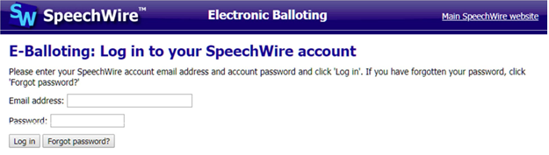
If you do not know your login, click “forgot password.” You will receive a link to reset your password and log in.

Once you are logged in, you will see a link for your ballot. (If you do not see a link, you may not be scheduled for that round. DO NOT LEAVE THE MEDIA CENTER! Wait for the tab staff to make sure all rooms have judges and to determine you are clear for that round.)
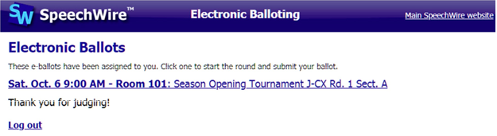
Your link will include the date of the tournament, the round, the room number, and which event.
For example, Thurs. Nov. 16 Rm1538 Debate Broward MAST Rd.2 IMP Section C
This indicates that you are judging the tournament for round 2, in room 1538 for the event: Impromptu.

***It is IMPERATIVE that once you are in the room, you immediately click START ROUND in SpeechWire.***
This lets us know that you have made it into your room, you can log in and that you are ready to judge. Otherwise, we may think that you did not get to your room, and we may start looking for another judge.
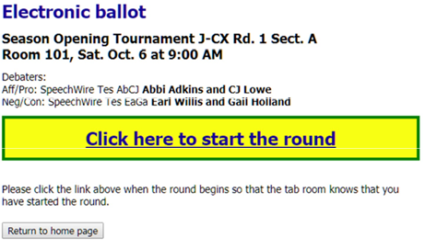
Once there,
For speech events, you will click on each competitor’s name to write the comments for them WHILE THEY ARE SPEAKING. You must type at least 50 characters for it to save. After you have seen all competitors speak, you can rank them and give speaker points. There are no ties. (1-7 ranks and 90-100 speaker points).

For debate events, you will type the comments of their arguments, rebuttals, questioning and overall debate. Then you will give each team in Public Forum, and each speaker in Policy and Lincoln Douglas speaker points. You will determine which team won and which team lost (should match the total speaker points). You will type your RFD (reason for decision) so the team understands why the other team won.

DO NOT DISCLOSE IF THE WON/LOSS OR WHAT PLACE THEY RECEIVED. Students will be very discouraged for the next round if they already know they did not do well in the first. If they ask, tell them it will be on the ballot.

